LAB 3
Sunnatilla Ramziddinov
230051

This is a guide to use the program made for Task 6 to decipher Vigenère-encrypted ciphertext.

Kasiski.c
First step is to launch Kasiski.c (make sure vigenere.txt is in the same directory as the program). The program will read the file, find “coincidences” (triplets), and print the distance between their first and second appearances in the text.

Then, based on the result, the user should calculate the Greatest Common Divisor (GCD) and enter it. The program will generate colums.txt to pass the processed text and GCD for other programs.

For the current problem, the GCD, as well as the key word length, is equal to 5.

Freq_analyzer.c
This program will read the colums.txt, divide the text into n columns based on GCD, and find frequency for each column (print top 3 letters).
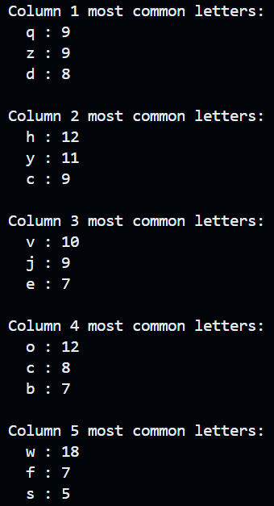
Then, the user should use Google Sheets to analyze the frequency and find the key word.
From colums.txt copy the GCD and insert into B1. Then, insert the string of clean text into A1. Use this formula in C1 to generate a table:
=ARRAYFORMULA(MID($A$1, (ROW(INDIRECT("A1:A"&ROUNDUP(LEN($A$1)/$B$1)))-1)*$B$1 + COLUMN(INDIRECT(ADDRESS(1,1)&":"&ADDRESS(1,$B$1))), 1))
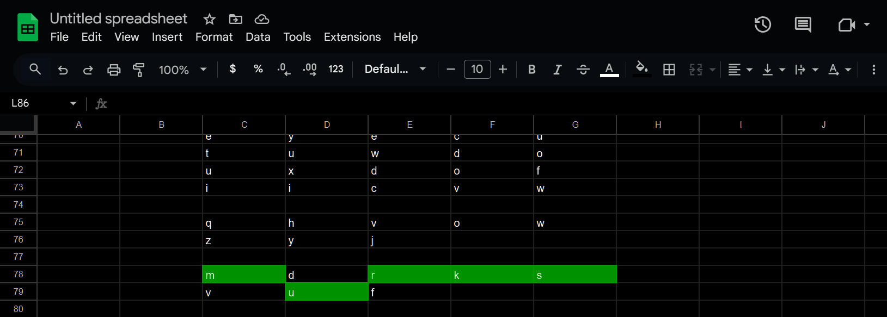
The user should determine letters with the highest frequency and compare them to “e” (the most common letter in English alphabet). Then, use the following website to calculate the shift:
https://www.101computing.net/cipher-wheel.html

Decipher.c
The last step is decipher. It will read the colums.txt and, based on the key word, decipher the entire text. The result will be saved in plain.txt.
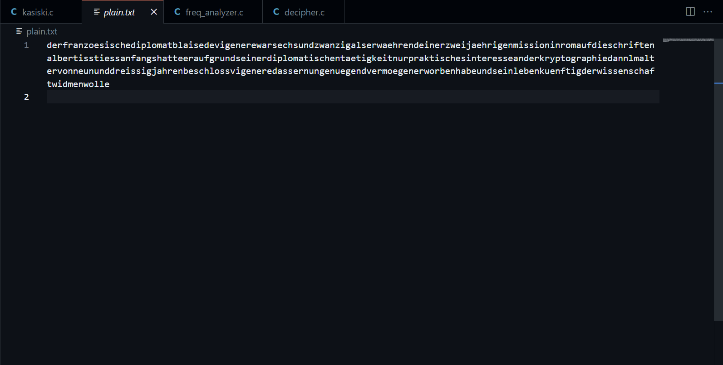

As for the given problem, from “der” I realized the text might be in German. I’m not a German speaker, so I asked Gemini to put spaces in necessary places to make it readable. The final result is:
"Der französische Diplomat Blaise de Vigenère war sechsundzwanzig, als er während einer zweijährigen Mission in Rom auf die Schriften Albertis stieß. Anfangs hatte er aufgrund seiner diplomatischen Tätigkeit nur praktisches Interesse an der Kryptographie. Dann, im Alter von neununddreißig Jahren, beschloss Vigenère, dass er nun genügend Vermögen erworben habe und sein Leben künftig der Wissenschaft widmen wolle."

